ROMANIA

Romania is located in central-southeastern Europe, covering 238,397 km² and standing out for its unmistakable Carpathian-Danubian-Pontic character. This unique positioning harmoniously brings together the imposing Carpathian Mountains (which dominate the country's relief), hills, plateaus, vast plains, the Danube River, and a generous opening to the Black Sea. The centerpiece of this varied nature is the Danube Delta, the second-largest and best-preserved delta in Europe, a true paradise of biodiversity and a biosphere reserve included in the UNESCO World Heritage.
The roots of the Romanian people date back to antiquity, when Roman troops led by Emperor Trajan of the Roman Empire conquered (parts of it) in the year 106 AD. As a result, an extensive process of Romanization took place, through which the Romanian people and their Latin-origin language were formed. This fascinating history is preserved in impressive vestiges, including the Dacian fortresses in the Orăștie Mountains (UNESCO sites) and the ruins of Sarmizegetusa Regia.
In addition to its millennial history, Romania possesses a valuable historical and cultural heritage recognized internationally. Among the most representative landmarks are Bran Castle—whose global notoriety is closely tied to the myth of Count Dracula from the novel published in 1897 by Bram Stoker, and the painted monasteries of Bucovina, such as the famous Voroneț blue. Also on the list of unmissable attractions are the wooden churches of Maramureș (including the Săpânța-Peri Monastery, the tallest wooden structure of its kind in the world) and the picturesque Saxon villages in Transylvania, such as Viscri, where King Charles III of the United Kingdom owns a traditional house.
The country’s cultural identity is completed by an extremely rich folk art, which includes authentic musical folklore and dynamic traditional dances like the hora and the căluș (recognized as UNESCO heritage). On a universal artistic level, one can find the Architectural Complex of Târgu Jiu created by the great sculptor Constantin Brâncuși—comprising the Table of Silence, the Alley of Chairs, the Kiss Gate, and the Endless Column—as well as the Merry Cemetery in Săpânța, famous for its brightly colored crosses and humorous epitaphs celebrating life.

TIMIȘOARA

Located in western Romania, Timișoara is the capital of the historical Banat region, a dynamic urban center characterized by strong multicultural diversity, where communities of Romanians, Hungarians, Germans, Serbs, and Jews have coexisted peacefully for centuries. The city is nicknamed the "City of Parks" for its numerous green spaces, such as Roses Park, and "Little Vienna" because of the distinctive Baroque and Art Nouveau (Secession) architectural elements in Victory Square, Liberty Square, and Union Square. Thus, its architectural heritage and multicultural character helped it win the title of European Capital of Culture in 2023.
The city's history underwent a spectacular transformation during the medieval period, more precisely in the 14th century, when King Charles Robert of Anjou moved the capital of the Kingdom of Hungary to Timișoara. The core of urban development formed around the medieval fortress, designed as a strategic stronghold surrounded by waters and marshes, whose emblem is Huniade Castle (the oldest building in the city), originally erected in the 14th century and rebuilt in the 15th century by John Hunyadi. This fortification was transformed into a modern Vauban-style defense system with the establishment of Habsburg rule in the early 18th century. Over time, the fortress lost its defensive role, so at the end of the 19th century, its walls were demolished, leaving only a few historical remnants, among which the imposing Maria Theresia Bastion stands out.
Timișoara has continually innovated through numerous European and national firsts, including the country's first brewery (1718), the first horse-drawn tram, and the first city in continental Europe with electric street lighting (1884).
In contemporary history, Timișoara holds a place of honor as a martyr city where from the 1989 Revolution broke out, an event that ended the communist regime in Romania.

VOCABULARY

Bună dimineața! = Good morning!
Bună ziua! = Good afternoon!
Bună seara! = Good evening!
Noapte bună! = Good night!
Ciao = Hello!/ Hi! (informal)
Bine ai venit! = Welcome!
La revedere! = Goodbye!
Salut = ciao, goodbye (informal)
Ne vedem mai târziu! = See you leter!
Ce mai faci? = How are you?
Cum te numești? = What’s your mane?
Câți ani ai? = How old are you?
Încântat de cunoștință (m)! / Încântată de cunoștință (f)!/ De asemenea!=Nice to meet you! / Likewise
Călătorie plăcută = Have a pleasant journey!
Te rog! = Please!
Mulțumesc! = Thank you!
Cu plăcere! = You’re welcome!
Ajutor! = Help!
Scuze! Mă scuzați! = I’m sorry! / Excuse me!
Intrare = Entrance / Entry
Ieșire = Exit
Da = Yes
Nu = No
Universitate = University
Facultate = Faculty
Cămin = Dorm
Hotel = Hotel
Restaurant = Restaurant
Street = Stradă
Parc = Park
Autobuz = Bus
Troleibuz/ Firobuz = Trolleybus
Tramvai = Tram / Streetcar
Vaporaș = Water bus – in Timisoara called vaporetto
Bicicletă = Bicycle / Bike
Spital = Hospital
Secție de poliție = Police station
Pompierii = Fire department
Ambulanță = Ambulance

CURRENCY

The official currency of Romania is the Romanian Leu (plural: Lei). The word “leu” actually means ”lion” in Romanian. Its currency code is RON, and the symbol you will see on price tags is lei. One leu is divided into 100 bani (singular: ban). Coins come in values of 1, 5, 10, and 50 bani, while banknotes come in 1, 5, 10, 50, 100, 200, and 500 lei.
Even though Romania is in the European Union, we don't use the Euro yet; our currency is the Romanian Leu (RON). Right now, 1 Euro is worth about 5.26 Lei. So, roughly speaking, 5 lei is about 1 euro (For quick math, just divide any price in lei by 5 to get the rough value in Euros. For example, a meal that costs 50 lei is roughly 10 Euros).
While major cities, restaurants, and supermarkets widely accept credit and debit cards (Apple Pay and Google Pay are also everywhere), it's still smart to have a little cash for small kiosks, traditional markets, or tips.

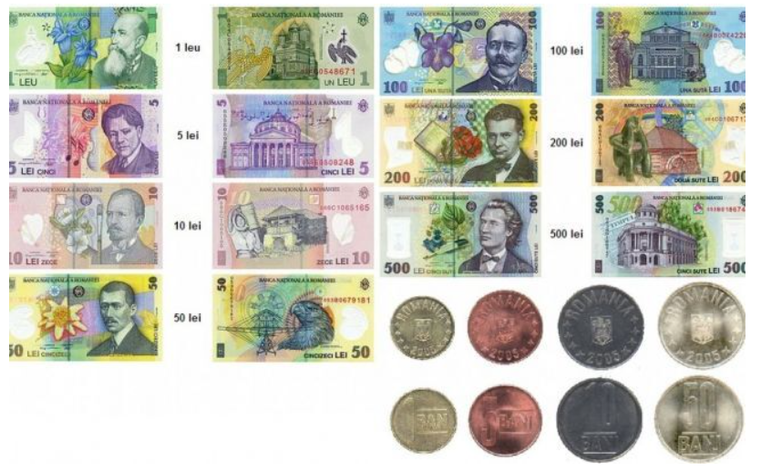

Fun fact: Romanian banknotes are not made of paper, but of polymer (plastic). This makes them waterproof, very durable, and almost impossible to tear!

If you need to exchange physical money in Timișoara, you can find good exchange offices (case de schimb valutar) right in the city. You can find several options on Bulevardul Eroilor de la Tisa (no. 10-12) and in the historic center on Strada Alba Iulia (no. 2). Alternatively, you can go to Iulius Mall (exchange offices are usually next to the entrance), which is very convenient and open until late.

EMERGENCY NUMBERS IN ROMANIA

If you face any emergency in Romania, just call 112. It is completely free of charge, available 24/7, and works for police, medical emergencies, and fire services. Operators generally speak English. If it's not a life-threatening emergency, you can also report specific issues. For example, 021 9595 is often used for local municipal police issues in Timișoara, but for anything serious, stick to 112.



TRANSPORT
To get to Timișoara, you have various transport options available: you can choose to travel by plane, landing at "Traian Vuia" International Airport, or take FlixBus coaches, which arrive at Normandia Bus Station, thus ensuring easy access

PUBLIC TRANSPORT IN TIMIȘOARA

Public transport in the city includes trams, buses, trolleybuses, and vaporettos. With a 1-hour ticket (Price: 5 lei), you can use multiple modes of public transport.
You can buy tickets (5 lei – 60 minutes) on the bus with a bank card, by SMS, or through the 24pay or mobilPay applications. You can buy paper tickets at STPT kiosks, and you must validate them when you board the bus. (For more details, check out https://stpt.ro/en/metode-de-plata/)
1-day pass costs 15 lei and can be purchased from STPT kiosks. Here’s a link with all the STPT kiosks in town: https://stpt.ro/en/retea-comerciala/.
If you want to get from point A to point B in the city, the easiest way is to just open Google Maps. Select the public transit option (the little train/bus icon), and it will show you the exact route, which bus, tram, or trolleybus to take, and even live tracking updates for when it arrives!
To check official schedules and timetables for all public transport lines, visit stpt.ro. For real-time tracking, look for STPT Live to see the exact GPS location of any bus, tram, or trolleybus on a map as it moves.

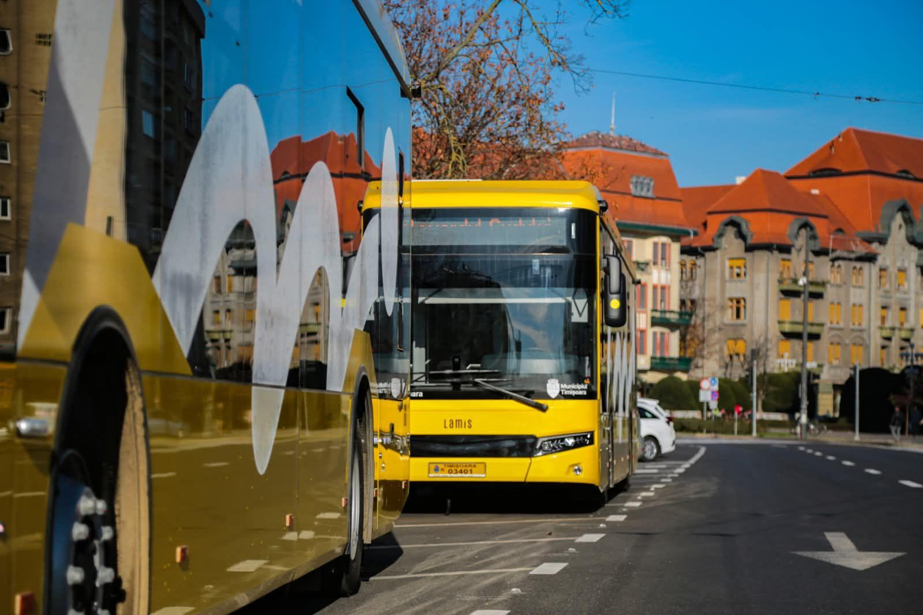

ACCOMMODATION: RENAȘTERII 2 STUDENT DORMITORY
Address: 24B Renașterii Street, Timișoara, România
Renașterii 2 is a modern student residence operated by the West University of Timișoara (UVT). Located on Renașterii Street, the dormitory provides comfortable accommodation and a range of facilities designed to support students' academic and social lives.
The residence offers studio-style accommodation for two students per room, with a private bathroom and essential amenities. Students can benefit from shared study areas, coworking spaces, equipped kitchens, dining areas, and laundry facilities.
The dormitory also includes air conditioning, an elevator, outdoor green spaces, a terrace, and bicycle parking. These facilities provide students with a practical and welcoming environment for living, studying, and socializing during their stay in Timișoara.
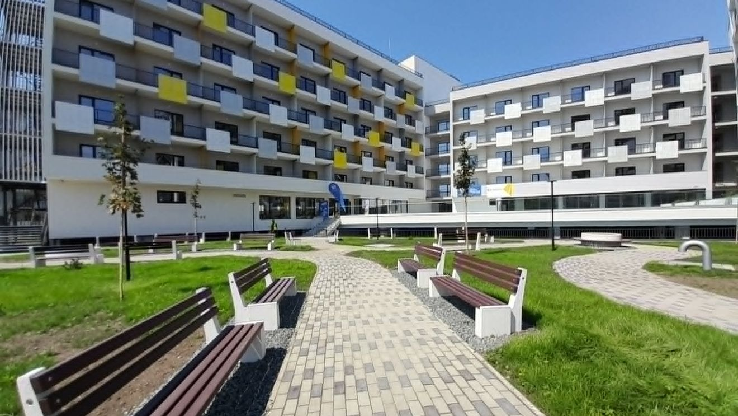
To find the best public transport routes from the dormitory to the city centre or the West University of Timișoara, you can use Google Maps for route suggestions and real-time travel information.
Our recommendation: The "Mihai Viteazu" boat station is a 12 minute walk from the dorm, and to get to UVT, it is recommended to get off at the "Catedrala Mitropolitană" station, from where you have approximately an 8 minute walk left to the university; alternatively, you can take tram 5C from the "Arena Electrică" station (in front of the Local Police), which is about a 7 minute walk from the dorm, and get off at the "Piața Libertății" station, from where you have about a 10-minute walk left to UVT.

The Student Complex (student campus)
The Student Complex is one of Timișoara's main student areas and a popular place for university students to live, socialize, and spend their free time. It is very close to UVT, so you can walk there.
Students can find restaurants, cafés, fast-food places, shops, and other everyday amenities in and around the complex. The area is also home to student accommodation buildings and university facilities, making it a convenient place to meet other students and experience student life in Timișoara.
Additionally, the student complex and/or the city center are the best areas to explore party opportunities, offering the city's most vibrant nightlife.
Beyond the Student Complex, the Bega River promenade and, especially, Timișoara's city center offer excellent opportunities to relax, socialize, and explore the local culture. From peaceful riverside walks and spending time with friends to discovering historical landmarks, cafés, and cultural attractions, these areas are perfect for experiencing the city's atmosphere and enjoying your free time.

Food & Drinks in Timișoara
Timișoara offers a variety of places to eat, from affordable takeaway options to restaurants in the city center. Students can find quick meals around the university area, while the historic center offers a wider range of international cuisines, cafés, and restaurants.
For some inspiration on what to try in Timișoara, you can check out Tripadvisor's restaurant recommendations.
Some of our personal favorites are located close to UVT. Here are three recommendations worth checking out!
Zaza Resto Pub – If you're looking for a place close to the university to grab a bite or enjoy a drink during your break, Zaza is just a one-minute walk away. You can even see it from the university windows! :) – here you will have lunch every day free of charge.
Riviere – Also very close to the university, just a five-minute walk away, Riviere sits along the Bega River and is a lovely place to enjoy a meal in a relaxing riverside setting. It's especially worth visiting if you enjoy pasta and want to combine good food with a pleasant view. And they have some very cute cats! :))
D'arc pe Mal – If you enjoy spending time by the river, D'arc pe Mal is a great place to grab a beer on a boat and spend an evening with friends. The venue is known for its music and occasionally hosts parties and special events, making it a fun spot to experience Timișoara's nightlife. And if you're lucky, you might even spot some ducks from there! :)

